Testimony on the Department of Electrical and Electronics Engineering
JSS Polytechnic, Mysore
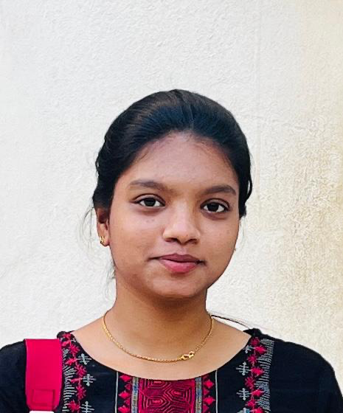
I am immensely proud and grateful to share my journey as a student of the Department of Electrical and Electronics Engineering at JSS Polytechnic, Mysore. These past three years have been a transformative chapter of my life—both academically and personally.
From the very beginning, the department laid a strong foundation in core electrical and electronics concepts. I was not only taught the theory with clarity, but I also received hands-on practical exposure, which deepened my understanding and gave me confidence to apply knowledge in real-world situations. The syllabus was made alive through the constant guidance, lab sessions, industrial visits, and real-time project work.
What truly sets this department apart is the unwavering support and dedication of the faculty and staff. They recognized my potential and consistently motivated me to push beyond my limits. The environment they created fostered both learning and leadership.
With the constant encouragement and mentorship of the department—and the cooperation and teamwork of my talented colleagues—I had the honor of securing:
- First Place in a National-Level Paper Presentation
- First Place Twice in State-Level Paper Presentations
These achievements would not have been possible without the vision and commitment of the department. Their focus on innovation, research, and personal growth shaped my journey in the best way possible.
Because of the nurturing environment, technical knowledge, and continuous guidance I received from my mentors and peers, I was able to become a topper throughout the three years of my diploma journey. The dedication shown by the department in helping every student reach their potential has truly left a lasting impact on me.
To the Department of Electrical and Electronics Engineering at JSS Polytechnic, Mysore—thank you for making me who I am today. I carry forward not just the knowledge, but also the discipline, passion, and confidence that you instilled in me.
With deepest gratitude,
Trupti Ananth Jain

